**DevOps Case-study challenge at Zeta**

1. Create a Two tier application infrastructure any cloud provider (Preferably in AWS) using Terraform, components that should be included are mentioned below
   1. VPC
   2. Security Group
   3. Subnet (Public and Private)
   4. NAT (Instance or service)
   5. EC2 instance
   6. Terraform should use modules for reusability

Solution:

I’ve created modules for VPC and EC2.

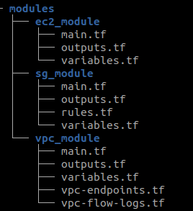

To create infra using these modules I’ve added terraform code files in the driver code folder.  
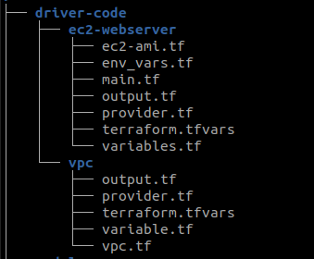

The user should first create VPC using terraform init and then terraform apply commands.

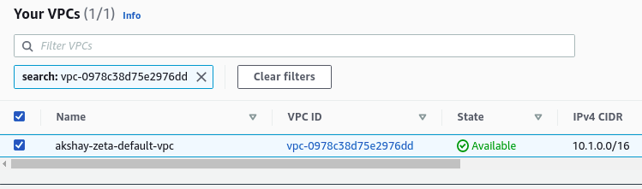

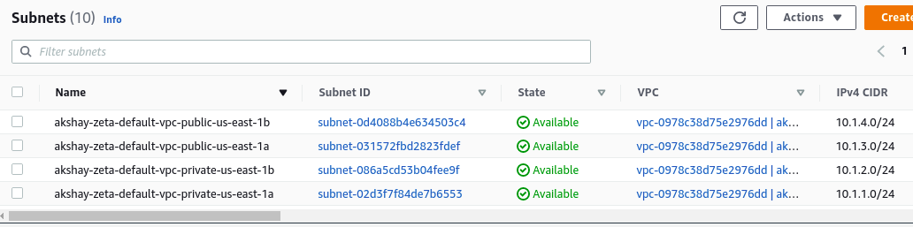

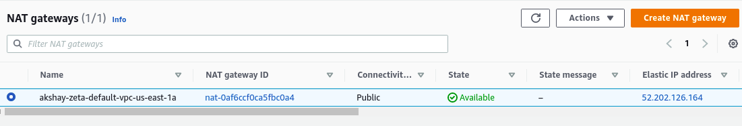

To launch EC2 server using terraform init and then terraform apply commands.

The webserver is launched in the public subnet and it is taking that subnet id from the data block.

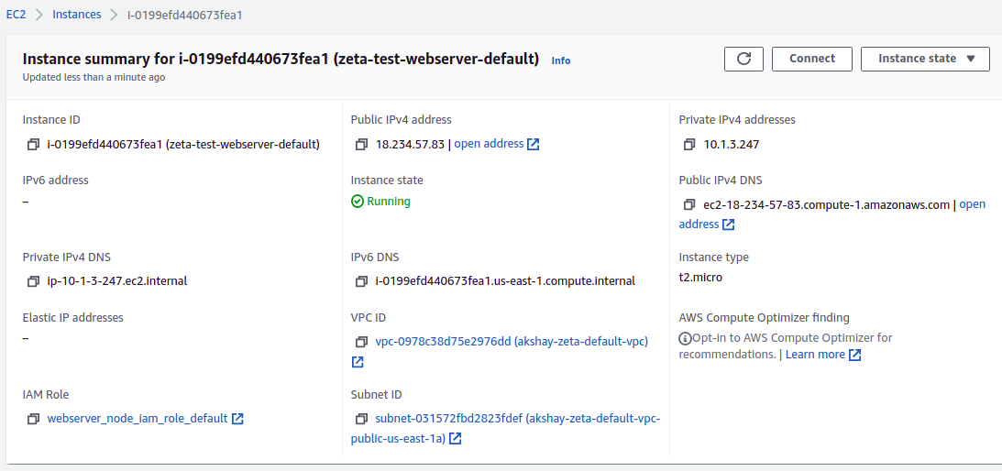

Apache is running on port 80 with our supplied html file using userdata

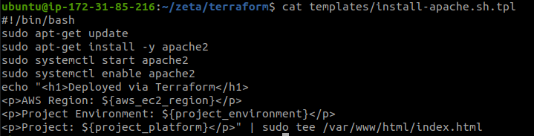

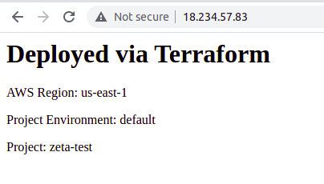

1. Shell script to take third most CPU & Memory consuming process, this should output to output file with the following properties
   1. Process Name
   2. % CPU used
   3. % Memory used
   4. PORT
   5. PID

Solution:

To extract processes details that consume high CPU and memory, I’ve used **ps** command.

To extract Port I’ve used **netstat** command and used awk & cut to get the port number as output.

